- To add dev tools, add the following dependency in pom.xml file.
  - 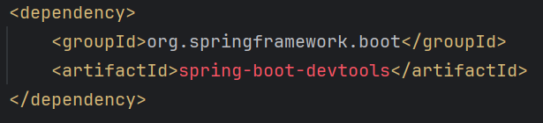
- IntelliJ idea specific settings:
  - Setting >> Build, Execution, Deployment >> Compiler
    - Select the option “Build project automatically”
    - So that the build will be automatically generated if u do any changes to the files (in running or debugging state).
  - Advanced Setting >>
    - Select the option “Allow auto-make to start even if developed applicatoin is currently running”

Auditing
- Auditing in Spring Boot allows you to automatically populate certain fields, such as creation and modification timestamps, as well as the user who created or modified the entity.
- Create Auditable base Entity using the following annotations:
  - @EntityListeners(AuditingEntityListener.class)
    - 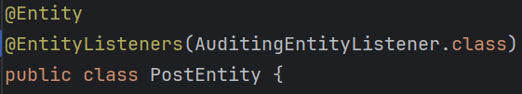
  - Now you can use the annotations @CreatedAt, @LastModifiedAt, @CreatedBy, @LastModifiedBy and create the fields inside the Entity.
    - 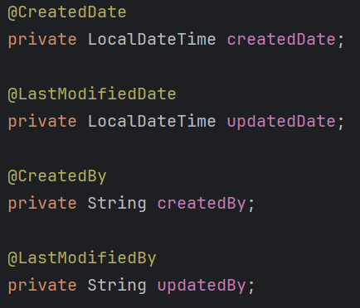
      - These are writtn inside entity; not DTO
  - Now, to make all these things work, you need to add @EnableJpaAuditing in any of the config file (file having @Configuration annotation)
    - 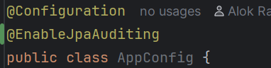
  - Now it’ll work properly when someone use post, put request.
    - Now if someone do some changes, it’ll be visible in the Database;
- Instead of writing @EntityListener in any particular entity, its better to create one class and write this annotation there. Whichever Entity wants to be audited, they can directly inherit that class.
- There is a annotation @MappedSuperClass,
  - lets say you want some common fields to be there in some Entities.
  - So, instead of writing those in every Entity, its better to write in a parent class and extend that class from the actual Entity class.
  - But, here the fields that are defined in the parent class will not be included in the table by default.
  - If you write @MappedSuperClass in the parent class, only then those fields will be part of the Entity table.
  - 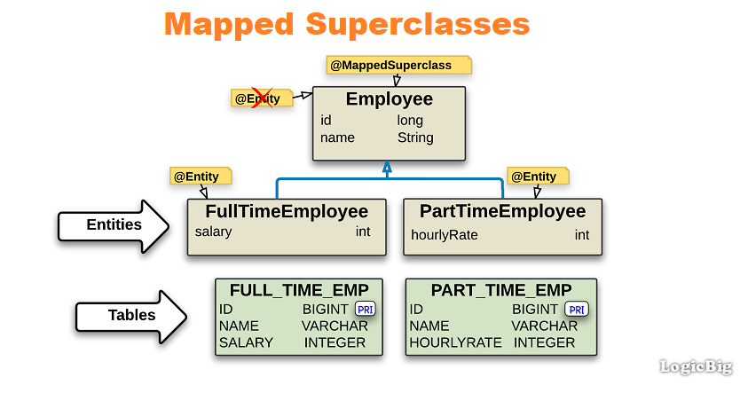
    - @MappedSuperClass is writtn in @Employee, so the entities (FullTimeEmployee, PartTimeEmployee) are having the id, name fields in their tables.
  - 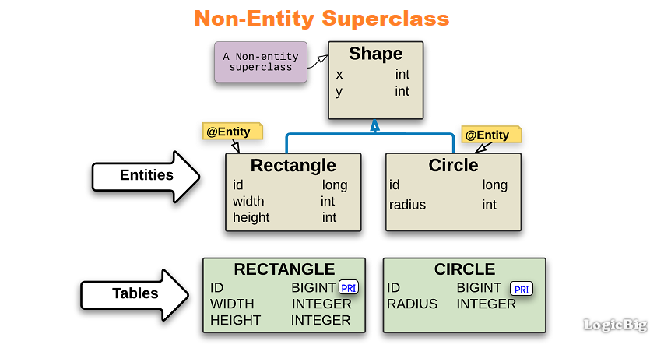
    - @MappedSuperClass is not written for the parent class Shape, so the Entities (Rectangle, Circle) are not having x, y fields in their tables.
- But till now, you’ll only get @CreatedAt and @LastModifiedAt , but the fields for @CreatedBy, @LastModifiedBy will be null only, as it doesn’t know who made the changes.
  - Its part of spring security to fetch the current user and add that user in the database for createdBy or updatedBy fields.
  - For now, we can use some dummy name for this.
- You need to write a class that implement the interface AuditorAware
  - 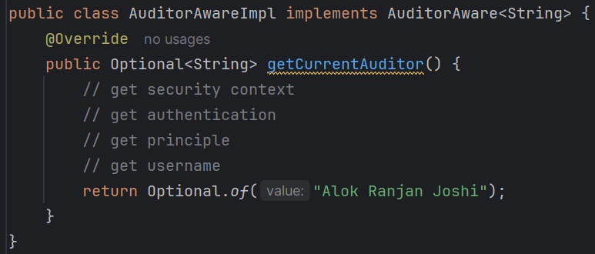
    - For now I am returning “Alok Ranjan Joshi” as the modifier/creator name.
- After this, you need to update the annotation @EnableJpaAuditing of the config class.
  - 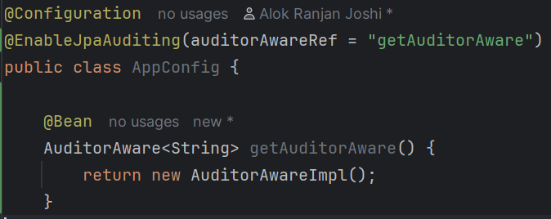
    - auditorAwareRef takes the bean name.
    - As the method name is getAuditorAware, by default method name becomes the bean name if you are not specifically mentioning a different name for the bean.
- F
- F

- So, All the steps are:
  - Create Auditable base Entity using the following Annotations
    - @EntityListeners(AuditingEntityListener.class).
    - You can create the fields using @CreatedBy, @LastModifiedBy, @CreatedAt, @LastModifiedAt.
  - If you are creating a super class for auditing, then use @MappedSuperClass on that parent class, otherwise the entities that inherit that parent class won’t contain the fields defined in that parent class.
  - Now write @EnableJpaAuditing in any config class (annotated with @Configuration).
  - Create an class implementing the interface AuditorAware interface.
  - Then edit the config file’s annotation @EntityListeners and pass the bean name (by default the method name) for the auditorAwareRef.

- Optimized steps:
  - Enable auditing (MANDATORY)
    - 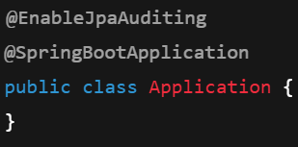
    - Better to write in the main application file (@SpringBootApplication)
  - Create a base audit class (BEST PRACTICE)
    - 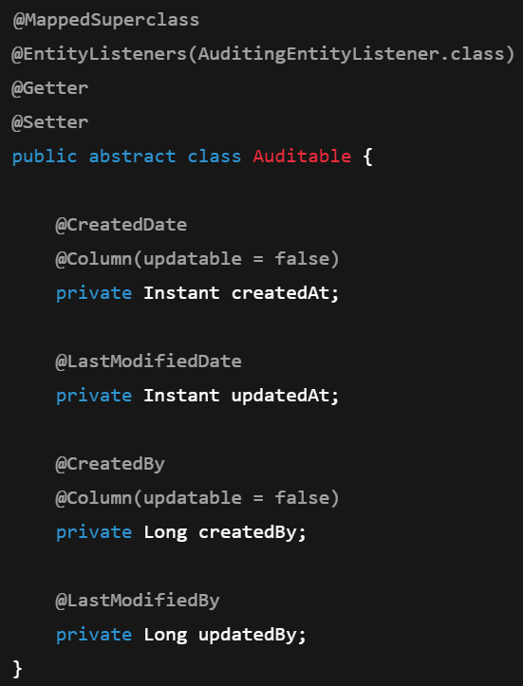
    - @MappedSuperClass is necessary; without that the fields will not be available in the entities that inherits this Auditable class.
    - AuditingEntityListener class contains all the methods that is being triggered to update the entity before create/update.
    - 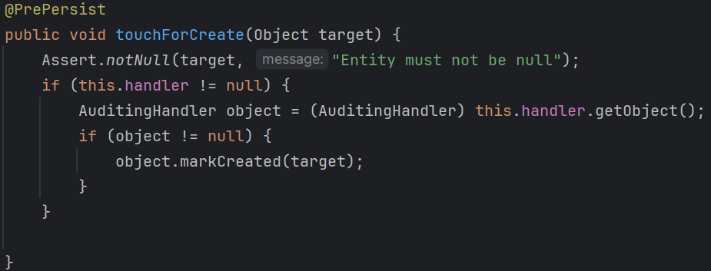
      - It is triggered before create event.
    - 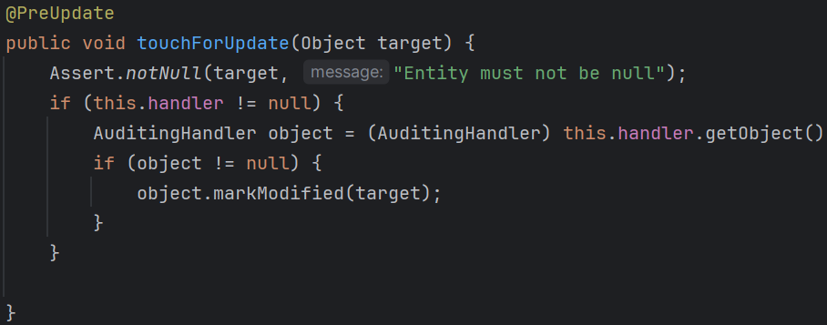
      - It is triggered before update event.
    - You can write your own methods using the annotations @PrePersist, @PreUpdate, @PreRemove that will be triggered before the respective operations.
  - Handling @CreatedBy and @LastModifiedBy
    - 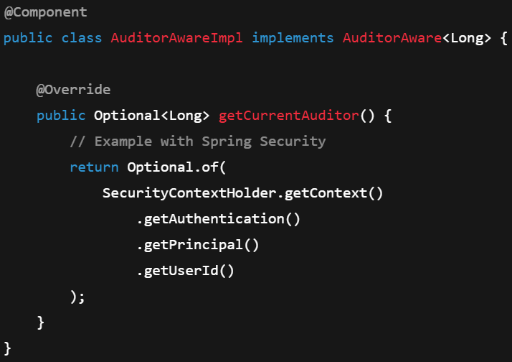
    - You need to create the bean of this class. Either use @Component or @Configuration, @Bean .
    - If you are having more than one classes that implements AuditorAware, and you are creating multiple beans, then you need to pass auditorAwareRef inside @EnableJpaAuditing.
      - 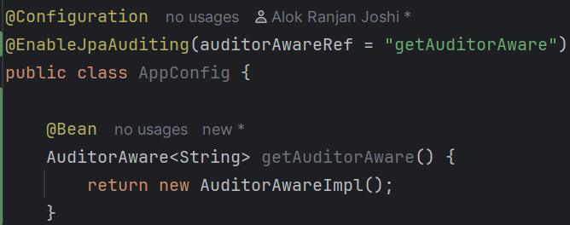
      - Like here, the bean name will be same as the method name i.e. getAuditorAware so I am passing the bean name in the auditorAwareRef.
      - But in case of single bean, no need of passing this.
  - Extend the base class in entities
    - 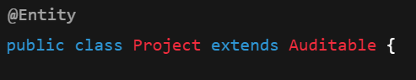
- Overall Annotations ------------------------------------------------------------------------
  - @EnableJpaAuditing(ﻤAuditingEntityListener.class)
  - @MappedSuperClass
  - @CreatedAt, @LastModifiedAt, @CreatedBy, @LastModifiedBy
  - @PrePersist, @PreUpdate, @PreRemove
  - AuditorAware class has to be implemented for @CreatedBy, @LastModifiedBy
  - ------------------------------------------------------------------------------------------
- F
- F
- F
- F
- F
- F
- F
- F
- F

